Claudia Moreno
Professor Hollon
ENGL-1302-23502
20 April 2017
Bullying in Middle Schools
1.Problem Overview
Bullying has been a problem over for many years now. Bullying is not also affecting students physically but also disrupts a person's emotional life through mobbing.Bullying and related forms of aggression are of increasing concern of students, as nearly 30% of youth are estimated to experience frequent involvement in bullying(Bradshaw,Sawyer,& O’Brennan,2006;Nansel et al.,2001).Bullying is the use of force, threat, or coercion to abuse, intimidate, or aggressively dominate others. the behavior is often repeated and habitual.However theirs programs in middle schools that should be offered. Offer peer mediation between students, improvisations, and classes about behavioral consequences.By teaching other students about bullying situations. Bullying is a growing problem in middle schools statistics.
2.Solution
Parents,school staff, and other caring adults can play a role to help prevent bullying. For example peer mediation program can help out bullying in middle schools. They can help kids understand bullying, keep the lines of communication open encourage kids understanding bullying and model how they should treat others.Peer mediation can help out resolve conflict through the use of communication through different students.Students will gain practice in training programs and talking about discipline. And also respect and how important it is to be able to communicate. Peer mediation benefits the students to have an opportunity to become confident communicators recognizing and understanding the problem. Middle schools benefit when students recognize their own ability to problem solve, and begin practice the skills of mediation as part of their everyday approach to solving problem. The goal of peer mediation in middle schools is to identify the problem and for other students to make a plan that will resolve the problem and help them out to avoid or repeating situation. Middle Schools are encouraged to identify the problem first and be responsible for coordination. And peer mediation is going to be a great problem solver for middle schools dealing with bullying and helping out the students in need. The study was initiated by a public school district to collect data on the prevalence of bullying and other indicators of school climate that would be used locally to facilitate data-based decision making regarding school safety (Bradshaw, C. P., Sawyer, A. L., & O'Brennan, L. M. (2007). Based on prior research by Olweus (1993) and Nansel et al. (2001), bullying was defined as occurring "when a person or group of people repeatedly say or do mean or hurtful things to someone on purpose. Bullying includes things like teasing, hitting, threatening, name-calling, ignoring, and leaving someone out on purpose. Peer mediation is a very helpful method for students in middle school to help them understand and talk it out and try to find out a solution to their problem.Students' and staff members' perceived social norms regarding bullies. For example, it was estimated that 40% of middle school staff estimated that the percentage of students being bullied in the past month was 32% less (Solberg & Olweus, 2003). The discrepancy between staff perceptions of the rates of frequent victimization and the student-reported rates appeared to be the most salient for middle school staff, with less than 1% of staff members reporting bullying rates similar to those indicated by students (33.7%). Similarly, middle schools staff underreported bullying prevalence rates, with only 5.1% of MS and 8.9% of HS staff accurately perceiving student victimization rates. (Solberg & Olweus, 2003). Peer mediation will be a great benefit for both faculty and middle school students to help them figure out a solution to their problem.
Figure 1
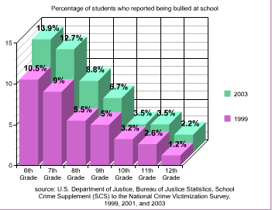
"Percentage of Students Who Reported Being Bullied at School." elquetzal. Web. 29 Mar 2011.

3. Benefits
Also middle schools should offer improvisation classes for students to act out scenarios in front of other students.Bullying is a growing problem in middle schools.Approximately 20% of children in the United States are affected by bullying (Glew, Rivara, & Feudtner, 2000).Bullying can threaten students physical and emotional safety at school and can negatively impact their ability to learn. The goal of having improvisation classes in middle schools can decrease the bullying.The present study examined longer-term school adjustment outcomes of middle school bullying and victimization in terms of academic achievement, disciplinary problems, and school attendance into high school. Having improvisation classes are going to benefit the students by playing different scenarios in front of other students. Teaching them how to add humor to a serious situation.Not only will the class help them understand the different situations about bullying but also is going to help them interact with different types of students.For example drama class where students get to act in plays and help the audience understand the story that they are trying to tell.Knowing that bullying in middle schools is a growing problem, drama would be a great benefit for the students.This class will benefit the students by teaching them how to use humor and acting out bullying situations.

Figure 2
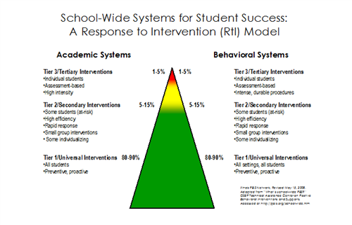
No Child Left Behind Act (NCLB) and the Individuals with Disabilities Education Act of 2004 (IDEA 2004)
4.Alternative Views
Having the peer mediation and improvisation classes will help out the students in middle school by helping them think that bullying can happen to anyone.And will help them mentally when they feel like they are in a bullying situation.Teachers and faculty staff should encourage lessons on bullying in middle schools.Some might say that is impossible to keep up with every middle school student and help them out.By having peer mediation and improvisation classes will help them talk to each other and interact with different students.

5.Conclusion
Middle school staff have a role to play on how to prevent bullying.Nowadays children are to themselves and school staff should be more involved with students.Teaching them the importance of communication and situations about bullying.Bullying is aggressive behavior that is intentional and involves an imbalance of power or strength,bullying has been part of school for so long and staff can make a change in bullying.Strategies can help identify and support children who are being bullied redirect the behavior of children who bully and change attitudes.Giving the students peer mediation and improvisation classes will benefit them and will make them have a different view of bullying.

Works Cited
Bradshaw, Catherine P., et al. "Bullying and Peer Victimization at School: Perceptual Differences between Students and School Staff." School Psychology Review, vol. 36, no. 3, Sept. 2007, pp. 361-382. EBSCOhost, dcccd.idm.oclc.org/login?url=http://search.ebscohost.com.dcccd.idm.oclc.org/login.aspx?direct=true&db=a9h&AN=26902186&site=ehost-live.
Feldman, Marissa A., et al. "The Effects of Middle School Bullying and Victimization on Adjustment through High School: Growth Modeling of Achievement, School Attendance, and Disciplinary Trajectories." Psychology in the Schools, vol. 51, no. 10, Dec. 2014, pp. 1046-1062. EBSCOhost, doi:10.1002/pits.21799.
McKenna, M., et al. "Bullying among Middle School and High School Students--Massachusetts, 2009." MMWR: Morbidity & Mortality Weekly Report, vol. 60, no. 15, 22 Apr. 2011, pp. 465-471. EBSCOhost, dcccd.idm.oclc.org/login?url=http://search.ebscohost.com.dcccd.idm.oclc.org/login.aspx?direct=true&db=a9h&AN=60556311&site=ehost-live.

